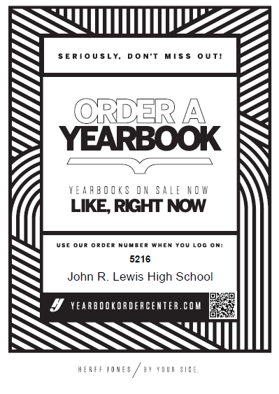

Yearbook Prices:

Yearbook $65.00 | 08/01/2023 -09/30/2023
Yearbook $70.00 | 10/01/2023 -01/29/2024
Yearbook $75.00 | 01/30/2024 -05/13/2024
Yearbook Distribution: $80.00 | When books are delivered -06/17/2024 *while supplies last

Yearbook ad prices:
*All ad sizes close on March 1, 2024

Size | Price
1 Full Page-Color | $190.00
1/2 Half Page-Color | $100.00
1/4 Quarter Page-Color | $65.00
1/8 Eighth Page-Color | $40.00

How to order:
- Go to yearbookordercenter.com and enter our school code: 5216
- Pick the package that you would like. If you would like to create an add for your child you could do here as well.

