What do the counselors do?

Help create a safe school environment where students can learn

Promote positive attitudes among students toward self, family, peers and community.

Assist students in learning how school performance relates to future opportunities.

Support students by teaching skills for achieving success.

Counsel students individually and in groups.

Work with students on developing their schedules relating to their future goals

Coordinate conferences and information sessions for all students

Help design interventions to enhance student success.

Collaborate with fellow counselors using best practices to help all students achieve success.

Provide assistance to parents, teachers and administrators.
John R. Lewis HS Support Services Team:
Director of Student Services
Amanda Hudson (703)924-8322

School Counselors
Jennifer Rogin-Marks (A-AS/AVID) 703-924-8327
Ruth Rodriguez (AT-CG/ESOL 1) 703-924-8325
Marisa Meiser (Ch-Gov) 703-924-8331
Curtiss Barnes (Gow-Lop) 703-924-8328
Vaughnetta Caldwell (Loq-Pa) 703-924-8488
Kellie Kirstein (Pe-Sj) 703-924-8330
Dave Checcino (Sk – Z) 703-924-8329

School Psychologist –
Mrs. Lewis – 703-924-8346

School Social Worker
Marcella Fulmore – 703-924-8485

Transcript Secretary – Diane Wink
SIA Operator – Sharon DeBardi

Student Services Secretary/Registrar
Katherine Kidd - 703-924-8322

College and Career Center Specialist
Carla Shaw – 703-924-8335

Parent Liaison
Norma Cruz (703) 924-8547
Alena Caroll 703-924-8307

CONFIDENTIALITY STATEMENT:
The information students share with the counselor is private and kept confidential. There are exceptions or conditions when the counselor must break confidentiality: *If the counselor believes the student is in danger. *If the counselor believes the student presents a danger to self or others. *If the counselor believes she needs to consult with someone else to help the student.

PLEASE NOTE THAT COUNSELING IN THE SCHOOL SETTING IS BRIEF IN NATURE. THE SCHOOL COUNSELOR IS AVAILABLE TO COORDINATE A REFERRAL TO A COMMUNITY AGENCY IF THERAPY IS INDICATED OR DESIRED.
John R. Lewis High School

Counseling Program

Mission: The Lee High School Student Services Department provides a data-driven, comprehensive school counseling program that enables equity and access for our diverse student population. We advocate for each student while fostering nurturing relationships that promote self-efficacy to maximize their social/emotional well-being, academic success, and college and career readiness. We prepare students to become global citizens who are productive and positive members of society, now and throughout their future.

Vision: As a result of accessing a comprehensive school counseling program, Lee High School students are successful, lifelong learners who continuously strive to reach their greatest potential. They are critical thinkers, effective communicators, problem solvers, and innovators in their desired career field. They collaborate with others and access resources and supports in order to be self-sufficient and resilient. Students utilize their diverse strengths and are positive and active leaders in their community.

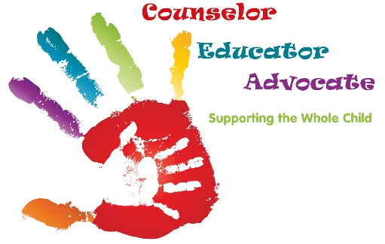

How and Why do Parents Contact the School Counselor?
Am I in trouble if I see the Counselor?

Your counselors are NOT the disciplinarians. A counselor is an adult who acts as your advocate! An advocate is someone who wants to listen to what you have to say and help you come up with some solutions. It doesn’t mean that counselors can solve the problem for you; it does mean that you have a safe place that you can go to when you aren’t sure what to do.

Concerns over student achievement Peer Conflict
Family/Student health problems New school registration and orientation
Test anxiety &/or preparation Discussing special needs of their child Early discussion of potential crisis Family difficulties or concerns Academic planning/scheduling

School Counselors Can Help in

Many Situations

“I’m new here and I’m having trouble making friends.”

“I’m nervous about asking my teacher questions.”

“I study a lot and I’m still not getting good grades.”

Programs at Lee High School

Become part of the Lee Culture!

RTI Process &/or 504 plans Parent/Teacher Meetings Parent Education

How does a student see the Counselor?

Ask your teacher for a pass

Ask the counselor to send you a pass Request of the counselor
Request of Principal or Asst. Principal Parent, teacher or friend request

Q. When can I see the counselor?

Your counselor is available before or after school and during the day with a pass from a teacher or a counselor.

Q. Where is the counselor’s office?

A. The counselors’ offices are located inside the main office.

