**How do we support students?**

*In 2018, we were awarded the prestigious RAMP (Recognized ASCA Model Program) designation by the American School Counselor Association (ASCA)*

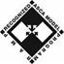

* **Help** create a safe school environment where students can learn
* **Promote** positive attitudes among students toward self, family, peers and community.
* **Assist** students in learning how school performance relates to future opportunities.
* **Support** students by teaching skills for achieving success.
* **Counsel** students individually and in groups.
* **Work** with students on developing their schedules relating to their future goals
* **Coordinate** conferences and information sessions for all students
* **Help** design interventions to enhance student success.
* **Collaborate** with fellow counselors using best practices to help all students achieve success.
* **Provide** assistance to parents, teachers and administrators.

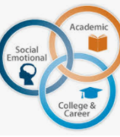

**John R. Lewis HS Student Services Team**

**Director of Student Services**

Amanda Hudson (703)924-8322

**School Counselors**

Jennifer Rogin-Marks (A-AS/AVID) 703-924-8327

Ruth Rodriguez (AT-CG/ESOL 1) 703-924-8325

Marisa Meiser (Ch-Gov) 703-924-8331

Curtiss Barnes (Gow-Lop) 703-924-8328

Vaughnetta Caldwell (Loq-Pa) 703-924-8488

Kellie Kirstein (Pe-Sj) 703-924-8367

Dave Checcino (Sk – Z) 703-924-8329

**School Clinicians**

Marcella Fulmore, Social Worker – 703-924-8485

Krystal Lewis, Psychologist – 703-924-8346

**Substance Abuse & Prevention**

Kori Joseph, Specialist – 804-596-0198

**Student Testing**

KJ Sachdeva, Coordinator – 703-924-8336

**College and Career Center**

Carla Shaw, Specialist – 703-924-8335

**Support Team**

Alena Carroll, Parent Liaison – 703-924-8307

Norma Cruz, Paerent Liaison – 703-924-8547

Sharon DeBardi, SIA – 703-924-8319

Katherine Kidd, Registrar – 703-924-8322

Diane Wink, Transcript Assistant – 703-924-8333

**John R. Lewis High School**

**Student Services Department**

**2020-2021**

6540 Franconia Rd.

Springfield, VA 22150

**Student Services:** 703-924-8322

*lewishs.fcps.edu*

**Mission:**  The Lewis High School Student Services Department provides a data-driven, comprehensive school counseling program that enables equity and access for our diverse student population.  We advocate for each student while fostering nurturing relationships that promote self-efficacy to maximize their social/emotional well-being, academic success, and college and career readiness.  We prepare students to become global citizens who are productive and positive members of society, now and throughout their future.

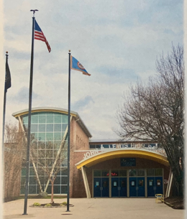

**Parent Corner**

Parenting Teenagers is not easy and can present challenges. We are here to support our parents as well as our students. The following are reasons why parents may want to contact us. Concerns

regarding:

* Student achievement
* Student mental health
* Peer Conflict
* Family/Student health problems
* New school registration and orientation
* Test anxiety &/or preparation
* Discussing special needs of their child
* Early discussion of potential crisis
* Family difficulties or concerns
* Academic planning/scheduling
* MTSS Support Process
* 504 Plan Development & Implementation
* Parent-Teacher Meetings

**Resources for Parents**

* Parent Resource Center [www.fcps.edu/resources/family-engagement/parent-resource-center](http://www.fcps.edu/resources/family-engagement/parent-resource-center)
* Advanced Academic Programs [www.fcps.edu/resources/family-engagement/advanced-academic-aap-family-resources](http://www.fcps.edu/resources/family-engagement/advanced-academic-aap-family-resources)

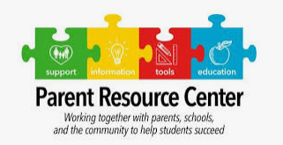

**Student Corner**

It is difficult to be a teenager and we are all here to help our students achieve. We are able to meet with our students any time. Students see us for:

* Academic guidance
* Social-emotional Concerns
* Acclimating to our school community
* Study skills
* College & Career exploration
* Scholarship applications
* College applications – transcripts, recommendations

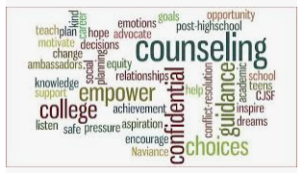

**Resources for Students**

* FCPS Academies [www.fcps.edu/index.php/academics/high-school-academics-9-12/career-and-technical-education-cte/academies-and-specialized](http://www.fcps.edu/index.php/academics/high-school-academics-9-12/career-and-technical-education-cte/academies-and-specialized)

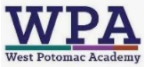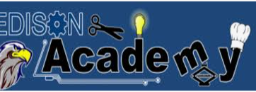

**Special Programs in Student Services**

Our department works hard to meet the needs of our students and community. The following are some of our programs:

* Small Group Counseling and Mentoring Programs
* MTSS (Multi-Tier Systems of Support) Approach
* Student Ambassadors
* CPP – College Partnership Program
* Governor’s School
* World Languages Credit Exam

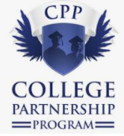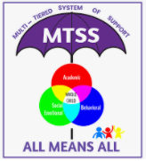

**Special Programs at Lewis HS**

* International Baccalaureate (IB) Program
* AP (Advanced Placement) Classes
* EduFuturo
* Liberty’s Promise
* AVID – Advancement Via Individual Determination
* Pathways to the Baccalaureate
* GenesysWorks
* Cosmetology & Auto Technology

