John R. Lewis High School
2-Hour Early Release Bell Schedule
March 26, 2021
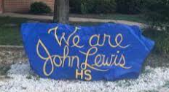

2nd Period  *Including Announcements | 8:20-9:45 (85 minutes)
6th Period | 9:55-11:15 (80 minutes)
8th Period | 11:25-12:45 (80 minutes)
Lunch for All – Grab & Go  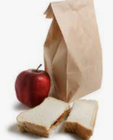  *Doors 1 and 13 | 12:45
Buses Depart  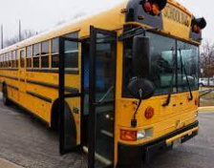 | 12:55

Additional Notes:
- We will not hold Advisory.
- Academy students will report to the library; no shuttles will run. Plan to remote in so bring your headphones.

