John R. Lewis High School
SIS Course Registration
Directions-for Students

Students, you will be registering for your classes for next year online in SIS! Follow these directions.

Log on to SIS  StudentVUE | https://sisstudent.fcps.edu/SVUE/Login_Student_PXP_OVR.aspx  [If you are new to FCPS or want to explore SIS features, including Course Registration, this link is helpful (see video): https://www.fcps.edu/node/31444]
Have the Course Selection Sheet handy | Have the Course Selection Sheet with you and use the Course Code Number to the left of the Course Name.
Add your Course Requests | 1. On the left side bar, select . Here is what the full screen looks like:  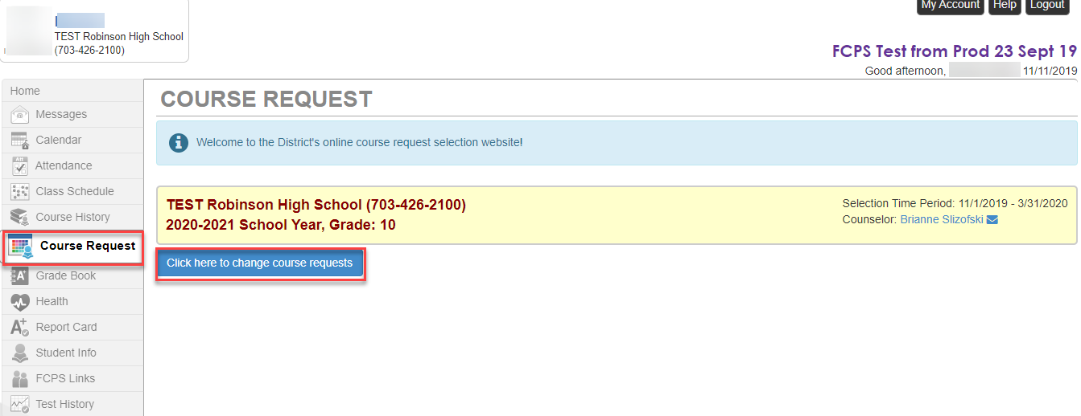  2. To enter course requests: click Click here to change course requests.  3. Search for each course using the Course ID and select Request.. Course IDs are found on the Course Selection Sheet. Use only these numbers in SIS.  4. Save your selections by clicking Click here to move selected requests to Selected Course Requests.  5. Repeat the steps above until you have a full course load – 7 classes.  6. (Optional) If you need to change/delete a course request, click Click here to change course requests. You will then be able to Remove Course Requests with the button Remove on the left. Here is a visual:  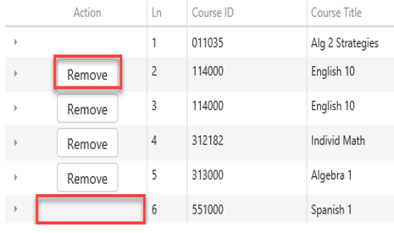  7. (Optional) Once you search for a course using the Course ID, you can click the triangle next to the course title to read about the class. Here is an example:  - The Course Catalog description can be viewed by clicking the Blue triangle next to the course title in the search results pane  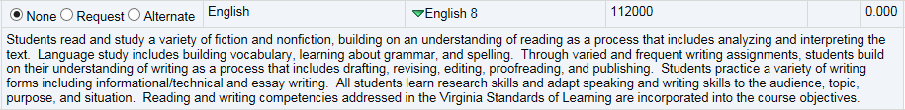  8. (FYI) Courses that are a match for the student’s current schedule are indicated as in the comments column.
Add your Elective Alternate Requests  (All students will enter 4 alternate electives)  Alternate courses  must be added in  preferential order | 1.To enter elective alternate requests: click Alternate Elective Requests.  2. Search for each course using the and select alternate.  3. Save your selections by clicking Click here to move selected requests to Selected Course Requests.
Resources and More Information | Explore John Lewis HS course offerings by visiting our School Website Student Services Academic Advising. Pay close attention to:  Course Selection Sheet…Electives Fair Videos…Course Catalogue

Additional Notes:
- Talk with your teachers, parents, and mentors about the courses you are interested in.
- Create a schedule that is well-balanced in terms of your interests, strengths, college/career paths, and any personal circumstances (sports, activities, jobs, outside of school responsibilities).
- Register for your courses in SIS prior to your Individual Academic Advising Meeting with your School Counselor. Be ready to discuss your schedule and if you have questions for your school counselor, write them down in advance so you don’t forget them.
- SIS Course Registration will be open to all students from January 4-March 12, 2021. Once you meet with your school counselor, your schedule will be locked and you won’t be able to make changes without discussing them with your counselor.

